
A12
Sreenidhi Institute of Science & Technology
(An Autonomous Institution)
Code No: 121MA06
B. TECH. II – Year I – Semester Examinations, MAY/JUNE, 2014 (Supplementary)
MATHEMATICS FOR BIOTECHNOLOGY - III (BT)

Time: 3 Hours Max. Marks: 70

Note: No additional answer sheets will be provided.

Part - A (Objective Type)
Max.Marks:20

Answer all QUESTIONS.
- Show that the eigenvectors corresponding to distinct eigenvalues of a real symmetric matrix are orthogonal.
- Find the characteristic equation of the matrix 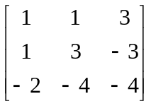.
- State Lagrange’s interpolation formula is used for how many intervals and write Lagrange’s interpolation for three ordinates.
- Evaluate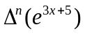.
- Construct the missing values in the following table.
X | 0 | 5 | 10 | 15 | 20 | 25
Y | 6 | 10 | --- | 17 | --- | 31
- Evaluate 
- Integrate approximately 
- Integrate approximately 
- Write Picard’s method of successive approximation to an ordinary first order differential equation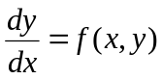with an initial condition 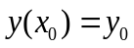.
- Expand y(x) by using Taylor’s series method at the point x = x_{0.}

Part – B
Max. Marks: 50

ANSWER ANY FIVE QUESTIONS. EACH QUESTION CARRIES 10 MARKS.
- a. Prove that =0, where A= .
b. Show that the transformation 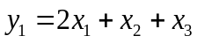, 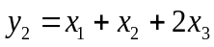 and 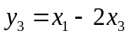is regular and write down the inverse transformation.

- a. For what values of x, the matrix
- Reduce the quadratic form 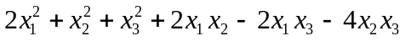to canonical form through an orthogonal transformation.

- a. If y_{x} is a polynomial for which fifth difference is constant and y₁+y₇ = -7845, y₂+y₆ = 686, y₃+y₅ =1088, find y_{4.}
b.Use Lagrange’s interpolation formula to fit a polynomial to the following data. Hence
find y(-2), y(1) and y(4).
x | -1 | 0 | 2 | 3
y | -8 | 3 | 1 | 2

- a. From the following table, estimate the number of students who obtained marks between 40 and 45:
Marks | 30-40 | 40-50 | 50-60 | 60-70 | 70-80
No. of students | 31 | 42 | 51 | 35 | 31

b. Compute f(27) from the data below:
X | 14 | 17 | 31 | 35
F(x) | 68.7 | 64.0 | 44.0 | 39.1

- a. By using the bisection method, find an approximate root of the equation sin x = 1/x, that lies between 1 and 1.5 (measured in radians). Carry out computations upto the 7th stage.
b. Using Newton’s method, find the real root of the equation 3x = cos x +1.

- a. A body of weight w tones, is accelerated upon by a variable force F tones weight. It acquires a speed of v mph after traveling y-yards where 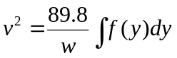. If w = 600 and F is given by the table below, estimate the velocity at the end of 400 yards from the starting point.
Y | 0 | 50 | 100 | 150 | 200 | 300 | 400
f(y) | 90 | 62 | 45 | 34 | 26 | 15 | 8

b. The velocity v (km/min) of a moped which starts from rests, is given at fixed intervals of time t (min) as follows:
t | 2 | 4 | 6 | 8 | 10 | 12 | 14 | 16 | 18 | 20
y | 10 | 18 | 25 | 29 | 32 | 20 | 11 | 5 | 2 | 0

Estimate approximately the distance covered in 20 minutes.
- a. Using Runge - Kutta fourth order method, find the solution of 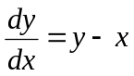with the initial condition 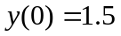on [0,1].
b. Using modified Euler’s method, find an approximate value of y when x = 0.3 for the IVP dy/dx = x + y and y(0) = 1.

- a. Define predictor-corrector method. [2 M]
- Apply predictor-corrector method, to find a solution of the differential equation
= x-y² in the range [0,1] for the condition y(0) =0. [8 M]
-- 00 -- 00 --

